CRIGGLESTONE ST. JAMES CE PRIMARY ACADEMY

Coronavirus (COVID-19): Contingency Plan
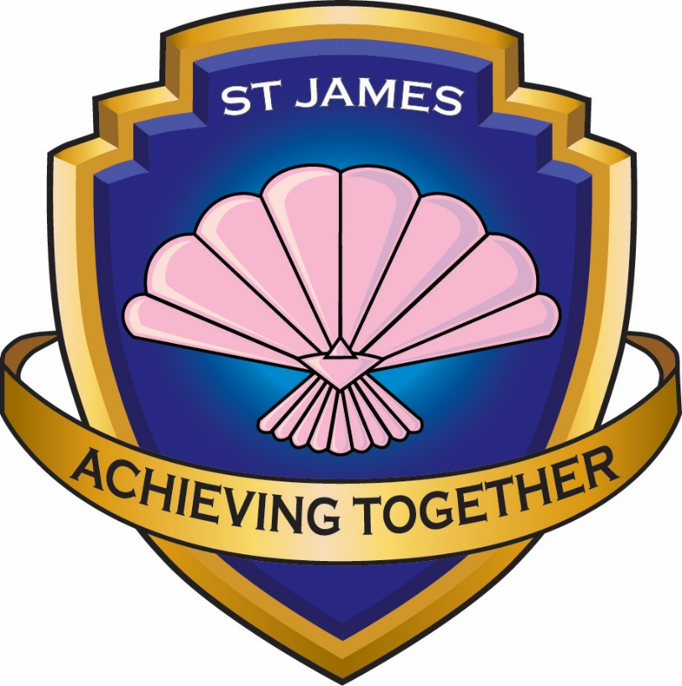

September 2021

Contents:
- The aim of this plan
- Restrictions to attendance
- Infection prevention and control
- Transport
- Teaching and learning
- Returning to school
- Exams and assessments
- Safeguarding
- Wraparound care
- Food provision
- Communication
- Monitoring and review

Please note: this plan has been created in line with the latest government advice regarding contingency planning as set out in the DfE’s ‘Contingency framework: education and childcare settings’ and the most current ‘Schools coronavirus (COVID-19) operational guidance’ documents. The government has made it a national priority that education and childcare settings should continue to stay open as much as possible during the coronavirus (COVID-19) pandemic. Any restrictions on education would only be as a last resort and should only be initiated following a ministerial decision on a case-by-case basis.
We have confirmed with the DfE that the ‘outbreak management plan’ that schools should have in place, according to DfE guidance, is the same as the contingency plan. We have used the phrase ‘contingency plan’ throughout.

The aim of this plan
If our local area sees an extremely high prevalence of coronavirus (COVID-19) infection rates and existing measures in our community have failed to reduce this, the appropriate authorities will decide which additional measures to implement to help contain the spread. These measures may involve implementing a number of restrictions, which could include the partial closure of schools and childcare settings in our area. Measures may also be necessary to help minimise the impact from new coronavirus variants.
This document outlines how the school will operate if further restrictions are implemented. The school will work closely with the local health protection team (HPT) and implement provisions as advised by the team. This framework is separate to the processes in place for managing outbreaks and operational challenges.
This is a live document that will be reviewed by the headteacher, in conjunction with other key stakeholders, as and when the situation develops.

Restrictions to attendance
The government has advised that all schools should continue to operate as normal and that all pupils should attend school unless required to self-isolate.
The contingency framework is designed to act as a containment measure where:
- There is extremely high prevalence of coronavirus.
- Other measures have already been implemented.
- There is a need to minimise the impact from a new coronavirus variant.
Restrictive measures, of the kind set out in the contingency framework, must not be implemented by schools without the explicit agreement of the DfE.
Restricting attendance in any form will only be used as a last resort, initiated following a ministerial decision. Where restrictions to attendance are implemented following government advice, they will be kept to a minimum, allowing for the maximum number of pupils to attend education; however, in all circumstances, priority will be given to vulnerable pupils and the children of critical workers to attend full time.
As part of their outbreak management responsibilities, LAs, Directors of Public Health, and HPTs may advise individual settings or a cluster of closely linked settings to limit attendance in one of the ways described in this section.
Where LAs judge that wider containment action is needed and wish to limit attendance within an area, they will work with their Regional Partnership Team to escalate a proposal to the central Local Action Committee command structure.
Unless advised otherwise, the school will allow all pupils to attend. If the contingency framework is implemented, the school will only allow the following pupils to attend on-site provision:
- Vulnerable pupils (as defined by the Government)
- Vulnerable pupils (as further identified by the Academy)
- Children of critical workers
- Pupils in Reception and Years 1 and 2, where advised by the DfE
High-quality remote education will be provided for all pupils not in attendance, in line with the Remote Education Provision: whole school closure and lockdown.
The school will lift restrictions as soon as it is advised by the government that it is appropriate to do so.
Infection prevention and control
The school’s Risk Assessment will be reviewed and updated, as needed. It will continue to be adhered to by all stakeholders as it meets the requirements set out in the DfE’s system of controls.
Any member of the school community who displays symptoms of coronavirus will be required to self-isolate and encouraged to get a test. Tests can be booked online or ordered by telephone via NHS 119. Critical workers, including school staff, have priority access to testing.
All schools are currently being provided with rapid-result lateral flow device (LFD) testing kits, which include PPE, to identify asymptomatic cases of coronavirus. Staff are encouraged to take the lateral flow tests twice a week and have to report the results to both the academy and to the Government using the Government LFD reporting website.
If a variant of coronavirus classed as a variant of concern (VoC) is identified within the school’s geographical area, the school will partake in targeted testing by the Department of Health and Social Care (DHSC) to help suppress and control any possible new cases. The school will also adhere to advice from Directors of Public Health in relation to the temporary reintroduction of face coverings.
If a pupil develops symptoms of coronavirus while on site, they will be taken to a designated isolation area while they wait to be collected. If required, the pupil will be supervised while they await collection. If the supervising member of staff is unable to maintain social distancing, e.g. due to the pupil’s age or needs, they will wear PPE. After the pupil has left the premises, any areas they were in will be cleaned. The pupil’s parents will be encouraged to get their child tested as soon as possible. The pupil will be required to self-isolate for at least 10 days – remote education will be arranged for them and will be available to them on the next school day.
If a staff member develops symptoms while on site, they will be directed to go home to self-isolate and to get a test. Cover arrangements will be put in place.
Any staff members or pupils who have been in close contact with a symptomatic individual at school will not need to self-isolate unless they develop symptoms themselves. Fully vaccinated adults, and pupils under the age of 18, who have been identified as close contacts of a positive case via the NHS Test and Trace service, will not need to self-isolate unless advised by a healthcare professional. Individuals also do not need to self-isolate if:
- They live in the same household as someone who has tested positive for coronavirus, unless they develop symptoms themselves.
- They have taken part in or are currently part of an approved COVID-19 vaccine trial.
- They are not able to get vaccinated for medical reasons.
Unvaccinated adults and adults who have only had one dose of the vaccine will need to continue to follow the rules on self-isolation if they have been identified as a close contact of a positive case.
Those aged 18 will continue to follow the same rules as under-18s until six months after their 18th birthday, when they will begin to follow the self-isolation rules for adults. Government guidance previously said 18 years and four months.
If a pupil or staff member is admitted to hospital with coronavirus, the school will contact the DfE helpline on 0800 046 8687 and select option 1. The school may be offered public health support in managing risk assessments and communicating with staff and parents.
It is important to think about taking extra actions if the number of positive coronavirus cases in the school substantially increases, as this could indicate that coronavirus transmission is happening in school. The following thresholds will be used as an indication of when to seek public health advice, whichever is reached first:
- Five children, pupils, students or staff who are likely to have mixed closely, test positive for coronavirus within a 10-day period
- 10 percent of children, pupils, students or staff who are likely to have mixed closely test positive for coronavirus within a 10-day period.
When a threshold is reached, the school will review and reinforce the testing, hygiene and ventilation measures already in place. The school will also consider:
- Whether any activities can take place outdoors, e.g. exercise, assemblies, or classes.
- Ways to improve ventilation indoors that will not significantly impact thermal comfort.
- One-off enhanced cleaning, focussing on touch points and any shared equipment.
- Whether the school’s risk assessment needs updating and will make any amendments as deemed suitable and appropriate, and including any measures advised by Public Health England, the Health Protection Team and the LA.
A director of public health may provide the school with advice that reflects the local situation. In areas where rates of positive cases are high, this could mean that the thresholds for extra actions are higher than the threshold set out above.
The school will seek additional public health advice if there is concern regarding transmission in the school, either by phoning the DfE helpline on 0800 046 8687 or in line with other local arrangements. The school will also refer to the government’s contingency framework for further information.
The individual’s close contacts at school – where they do not fulfil the criteria outlined in this section of the contingency plan – will be contacted by the NHS Test and Trace, and advised to take a PCR test. If more individuals test positive, the school will follow advice from the local HPT, which may include requiring more people to self-isolate. Staff who do not need to isolate and young people under the age of 18 years and six months who have been identified as a close contact should continue to attend school as normal.
As the result of an outbreak during step 4 of the coronavirus recovery roadmap, a temporary requirement could be implemented for staff to resume wearing face coverings in areas other than crowded spaces where they are likely to come into contact with others they would not normally meet. This may include face coverings being reintroduced in communal areas for members of staff. The school may also be required to reintroduce the use of bubbles in order to resume social distancing and limit the transmission of coronavirus. The school will adhere to any conditions set out by the local HPT.
Transport
Pupils and staff attending school will be encouraged to walk or cycle wherever possible and to avoid public transport. The government has removed the legal requirement to wear face coverings but expects and recommends that they are worn in enclosed and crowded spaces where you may come into contact with people you don’t normally meet – this includes public and dedicated transport to schools. If pupils and staff need to use public or dedicated transport, they may be asked to wear a face covering while travelling, unless exempt in line with government guidance, e.g. due to a disability.
Transport services to and from the school will continue to operate as normal during times of local restriction where pupils are still attending. In the event that such services are not able to operate as normal, the headteacher will consider alternative options and communicate these to all parents and pupils in advance.
Teaching and learning
If restrictions to on-site education are required, the school will offer immediate access to high-quality remote education for all pupils who are required to remain at home. All remote learning will be delivered in line with the school’s Remote Learning Agreement and Remote Learning Offer: In case of whole school closure.
The school will use a range of teaching methods to cater for all different learning styles. This includes:
- Recorded lessons from accredited online teaching providers, for example: Oak National Academy and White Rose Maths and commercially available websites such as: Read, Write Inc videos on Youtube, BBC Bitesize, BBC Newsround and Picture News.
- Some pre-recorded videos will be used, with class teachers giving instructions on tasks, or modelling and demonstrating how to use strategies to complete problems.
- Live Meet and Greet sessions to support wellbeing and maintain the link between home and school, both between children and between children and adults in school.
- Comprehension questions and quizzes will be used as a form of assessment and to support teaching planning.
Teachers will ensure lessons are suitable to the class group’s age and ability, inclusive for all pupils, and will be adapted, where necessary, to account for the needs of disadvantaged pupils and pupils with SEND.
When teaching pupils who are working remotely, teachers will:
- Set assignments so that pupils have meaningful and ambitious work each day.
- Deliver a planned, coherent and well-sequenced curriculum which allows skills to be built incrementally.
- Provide frequent, clear explanations of new content through high-quality curriculum resources, including through educational videos.
- Assess progress by using questions and other suitable tasks and use assessment to ensure teaching is responsive to pupils’ needs and addresses any critical gaps in pupils’ knowledge.
- Adjust the pace or difficulty of what is being taught in response to questions or assessments, including, where necessary, revising material or simplifying explanations to ensure pupils’ understanding.
- Provide opportunities for interactivity, e.g. questioning and reflective discussion in Live Meet and Greet sessions.
- Provide scaffolded practice and opportunities to apply new knowledge.
- Enable pupils to receive timely and frequent feedback on how to progress, using digitally-facilitated or whole-class feedback where appropriate.
- Plan a programme that is of equivalent length to the core teaching pupils would receive in school, ideally including daily contact with teachers.
In exceptional circumstances, the school may reduce its curriculum offering to enable pupils to cope with the workload – the headteacher will assess this need, keeping pupils’ best interests in mind, and will not take the decision lightly.
Teachers will continue to make use of formative assessments throughout the academic year, e.g. quizzes.
The school will utilise the support available through the DfE’s ‘Get help with technology during coronavirus (COVID-19)’ scheme. Under the scheme, the school can order laptops, tablets and 4G wireless routers to support the following groups of pupils if they do not have access to a digital device or the internet through other means:
- Pupils in Years 3 to 6
- Clinically extremely vulnerable pupils across all year groups who are not attending school in line with the current government and/or clinical advice at that time
- Pupils in all year groups whilst attending school on a hospital site
- Pupils in any year group who have been advised to shield because they, or somebody they live with, are clinically extremely vulnerable
Before distributing devices, the school will ensure:
- The devices are set up to access remote education.
- Appropriate safeguarding controls and support are in place to help pupils and their families use the devices safely.
Once devices are ready for collection, the school will either arrange for them to be collected by families from school or delivered to pupils’ homes, ensuring infection control measures are adhered to as part of this process. A parent/carer will be required to sign the academy’s Remote Learning: Loan of equipment/resources agreement before a device is handed over.
Remote learning will be available through Microsoft Teams. Work will be uploaded the evening before the day, giving parents time to download any documents and familiarise themselves with learning. Children’s work should be submitted by 7pm on the evening that work is set. For example, Monday’s work will be available to parents from 8pm on Sunday evening. The work should be completed by the child on Monday and should be uploaded onto Teams, in the child’s account on the Monday evening by 7pm.
Parents/carers/children can contact the class teacher through the Teams newsfeed on the general channel if they have any questions about the work. Alternatively, they can contact teachers on the class email account. This is only available when whole class remote learning needs to take place.
Teachers will mark tasks and return it to children on the next working day. It will be returned to the child on their Teams account.
If any children have difficulty using their Microsoft Teams account they should contact the school who will try to help and suggest possible alternatives of the problems cannot be solved.
For children in Reception, teachers will upload work on Tapestry in the ‘documents’ section. Parents will be able to download work and then return completed work as an observation, at the end of each day.
Every morning, children will be able see and hear their teacher reading a story. The class teacher, or another adult in school, will film themselves reading a short book / a chapter of a book. These will be uploaded each morning and will be available to be watched from 9am. Class teachers will also record a Morning Welcome every morning, giving an overview of the learning for the day and giving comments on any work received from the day before.
Returning to school
The headteacher will work with the LA to ensure pupils only return to school when it is safe for them to do so. Prior to the return of more pupils and staff, all relevant risk assessments will be reviewed.
Where advised to do so by a Director of Public Health and/or the local HPT, the school may encourage staff to undertake LFD tests at home prior to their return to school and/or for a period of time following their return. The school will continue to recognise that testing is voluntary.
The headteacher will inform staff, pupils and parents, prior to the return to school, whether any further restrictions, such as the use of bubbles and face coverings, have been resumed.
After a period of self-isolation, or the relaxation of restrictions, the headteacher will inform parents when their child will return to school.
The headteacher will listen to all concerns that parents may have about their child returning to school and will advise them of the measures in place to ensure the safety of their child.
Exams and assessments
The school will remain open for any exams and assessments planned in line with current government guidance.
Wherever necessary, we will implement additional mitigations to ensure the safe delivery of exams and assessments, which may include:
- Staff wearing face coverings in communal areas.
- Two-metre spacing between all desks, where directed.
- Additional controls for candidates who are classed as clinically extremely vulnerable. This may include measures such as seating them in a separate room to other candidates or, in exceptional circumstances, at the candidate’s home.
Safeguarding
Ensuring safeguarding arrangements remain effective during periods of restricted attendance is a key priority. Our Child Protection and Safeguarding Policy has been updated to include provisions for keeping pupils safe during the coronavirus pandemic, both at home and in school – we will continue to follow these procedures for pupils who remain at home, where appropriate, until all pupils are able to return to school.
We will continue to ensure that:
- The best interests of pupils always come first.
- If anyone in the school has a safeguarding concern about a pupil, they act immediately.
- A DSL or deputy DSL is always available.
- Unsuitable individuals are not permitted to work with pupils or come into contact with pupils whilst on site.
- Pupils who remain at home are protected when they are online.
A trained DSL or deputy will remain on-site where possible. Where this is not possible, e.g. they are required to self-isolate, the school will ensure that the DSL or deputy, or a DSL or deputy from another school, are available to contact at all times. In addition, the headteacher will take responsibility for coordinating safeguarding on-site during this time.
Food provision
We will provide meal options for all pupils who are attending school.
We will provide FSM or food parcels to eligible pupils who are not attending school, where they:
- Are self-isolating.
- Have had symptoms or have tested positive for Covid-19.
- Are not attending due to the implementation of local restrictions advised by the government.
The school will work closely with the catering team and their food providers to prepare meals or food parcels, for collection or delivery, to eligible children during their time at home. The Government’s FSM food voucher scheme will also be used, if this is available.
Communication
The school will communicate its plan for addressing any imposed restrictions with parents, including in relation to:
- Opening arrangements.
- Access for specific targeted groups where applicable, such as certain year groups, vulnerable pupils and children of critical workers.
- Any reviews of the school’s protective measures as part of our risk assessments.
- The arrangements for remote working.
All relevant stakeholders will be kept up-to-date with the circumstances of any imposed restrictions and how these affect the school as the situation develops.
If any member of the school community wishes to discuss any concerns relating to the school’s provision during this period, they should contact the following as appropriate:
- Staff – their line manager
- Pupils – their class teacher or member of pastoral staff
- Parents – contact the school in the following order:
  - The school office
  - The assistant headteacher
  - The deputy headteacher
  - The headteacher
Monitoring and review
This plan will be reviewed continually, by the headteacher, in line with guidance from the government and Public Health England (PHE).
Any changes to the plan will be communicated to all relevant stakeholders

Date policy last reviewed: | 2.7.21

Reviewed by: Chair of Resources Committee
Review Date: July 2022

