CRIGGLESTONE ST. JAMES CE PRIMARY ACADEMY

Remote Learning Plan (when school is open)

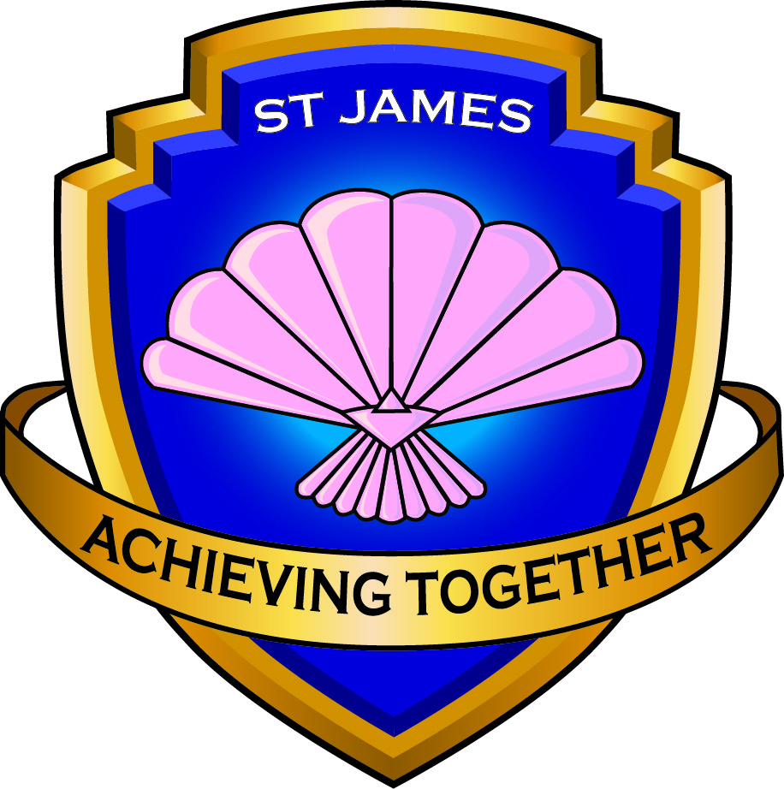

January 2021

Remote Learning Plan
The Remote Learning Plan at St James is to be used when school is open as normal but children may have to learn at home because of Covid-19. The plan takes into account many different scenarios of why a child may not be in the school building and how remote learning will be used to minimise disruption to children’s learning.

We have completed a Parent Survey and have taken Parent voice and teacher voice into account when devising this plan. If parents do not have access to technology at home, the Academy will liaise with parents to help them in the most appropriate way. This could be through providing access to technology or through offering home learning packs, consisting of printed instructions and tasks.

The Academy will agree safeguarding rules with parents and children, both in home and at school, to ensure the safety of all children.

Scenario | Actions
CHILD self-isolating (not ill) | Day 1:  - A home learning pack will be sent home with the child / collected by parent / delivered by school.  - Learning will include: Reading, Writing, Maths, Phonics (if appropriate), Wider Curriculum and spellings.  - Work should be sent to the class email address.  Day 2 onwards:  - Reception:  - Teachers to upload work on to Tapestry. Or home learning packs will be available if parents have issues with Teams/Tapestry.  - Work set will be in line with work done in school. Completed work should be uploaded onto Tapestry and an adult will provide feedback.  Parents can send completed work to school via the class email if they experience problems with Tapestry.  - Key Stages 1 and 2:  - Teacher to upload work on to the class Teams page. Or home learning packs will be available if parents have issues with Teams. Work set will be in line with work done in school. Completed work should be uploaded onto Teams and an adult will provide feedback.  Parents can send completed work to school via the class email if they experience problems with Teams.  Weekly welfare checks will take place whilst the child is self-isolating. Home visits may be made if parents do not answer.  Any concerns will be logged on Safeguard, as is normal practice.
Bubble closure due to a confirmed positive case | Day 1 (if children are in school when the bubble closes)  - Children take home a home learning pack, consisting of Reading, Writing, Maths, Phonics (if appropriate), Wider Curriculum and Spellings for that day.  - Children who request/need it, will take home an exercise book and a pencil to support remote learning. Parents can request this when they are informed that the bubble is closing.  Day 2 onwards:  - Reception: Daily work will be uploaded onto Tapestry by the class teacher. Children can return work on Tapestry and adults will send feedback.  - If the class teacher is ill, another teacher/member of SLT will set appropriate work  - Year 1-6: Work will be uploaded onto Teams. Children can download work and return it on Teams. Adults will respond to work and give feedback through Teams.  - If the teacher is ill, another teacher within the Keystage/member of SLT will set appropriate work.  Weekly welfare checks will take place whilst the bubble is at home. Home visits may be made if parents do not answer.  Any concerns will be logged on Safeguard, as is normal practice.
Bubble closure due to teacher being a close contact | Where possible, children will remain in school and an HLTA / supply teacher will be used.  - If the teacher is not ill, they will continue to set work and will send this in to school to be used.  - If the teacher is ill, another teacher within the Keystage/member of SLT will set appropriate work.  - If the bubble cannot stay in school, due to a lack of staff, school will follow the ‘bubble closure’ procedure, outlined above.
1:1 SEN ESA is self-isolating | - Another adult in school may be redeployed to work with the child.  - A supply 1:1 SEN ESA may be used to support the child.  The SENDCo will liaise with adults and families as appropriate.  If the 1:1 SEN ESA tests positive the child and other close contacts will be informed to self-isolate and above procedures, regarding children self-isolating, will apply.
School closure due to Government instruction / lockdown | - School remains open to vulnerable and keyworker children.  - Teachers remain in school, along with ESAs, where possible, depending upon the demand of school places required from parents. School will look at ways to reduce the numbers of adults in school at any one time.  - Work is set and uploaded onto class pages on Tapestry (in Reception) Teams (Key Stage 1 and 2).  - Teachers remain in class, teaching to children in school. ESAs support in class, provide intervention support, support those on EHCPs / SMTLPs, working on targets set and complete weekly welfare checks.  Children in school - teachers continue to teach lessons in school, using the ones they have uploaded onto Tapestry/ Teams.  Children at home – access remote learning through Tapestry/Teams.

